use sample_data;

**#DEMOGRAPHIC INSIGHTS**

**#1 .Who Prefer Energy Drinks more ?**

SELECT Gender, COUNT(dr.Respondent_ID) AS No_of_Respondent

FROM dim_repondents dr join fact_survey_responses fsr ON dr.Respondent_ID=fsr.Respondent_ID

GROUP BY Gender

ORDER BY No_of_Respondent DESC;

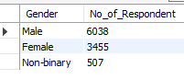

**##2. Which age group Prefer Energy Drinks more?**

SELECT Age, COUNT(dr.Respondent_ID) AS No_of_Respondent

FROM dim_repondents dr JOIN fact_survey_responses fsr ON dr.Respondent_ID=fsr.Respondent_ID

GROUP BY Age

ORDER BY No_of_Respondent DESC;

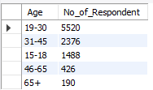

**#3.which type of marketing reaches the most youth?**

SELECT Marketing_channels ,COUNT(*) AS count_reaches

FROM dim_repondents dr JOIN fact_survey_responses fsr ON dr.Respondent_ID=fsr.Respondent_ID

WHERE Age='15-18' OR Age='19-30'

GROUP BY Marketing_channels

ORDER BY count_reaches DESC ;

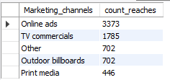

#**CONSUMER PREFERENCES**

**#1.what are prefered ingredient of energy drink among respondants?**

SELECT Ingredients_expected, COUNT(dr.Respondent_ID) AS no_of_respodent

FROM dim_repondents dr JOIN fact_survey_responses fsr ON dr.Respondent_ID=fsr.Respondent_ID

GROUP BY Ingredients_expected

ORDER BY no_of_respodent DESC;

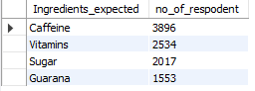

**##2.what packaging preferences respondants have for energy drink?**

SELECT Packaging_preference, COUNT(dr.Respondent_ID) AS no_of_respodent

FROM dim_repondents dr JOIN fact_survey_responses fsr ON dr.Respondent_ID=fsr.Respondent_ID

GROUP BY Packaging_preference

ORDER BY no_of_respodent DESC;

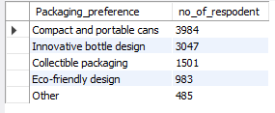

**#COMPETETION ANALYSIS**

**#1.Who are current market leaders**

SELECT Current_brands, COUNT(Respondent_ID) AS no_of_respodent

FROM sample_data.fact_survey_responses

GROUP BY Current_brands

ORDER BY no_of_respodent DESC ;

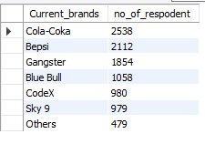

**#2.what are primary reason consumers prefer those brands over ours?**

SELECT Reasons_for_choosing_brands, COUNT(Respondent_ID) AS no_of_respodent

FROM sample_data.fact_survey_responses

GROUP BY Reasons_for_choosing_brands

ORDER BY no_of_respodent DESC;

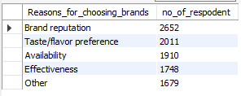

**##how effective are different marketing strategies and channels channels in reaching our customers?**

SELECT Marketing_channels, COUNT(Respondent_ID) AS no_of_respodent_codex

FROM sample_data.fact_survey_responses

WHERE Current_brands='CodeX'

GROUP BY Marketing_channels

ORDER BY no_of_respodent_codex DESC ;

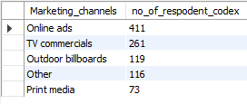

**#MARKETING CHANELS AND BRAND AWARENESS**

**#1.which marketing channel can be used to reach more customers?**

SELECT Marketing_channels, COUNT(Respondent_ID) AS no_of_respodent

FROM sample_data.fact_survey_responses

GROUP BY Marketing_channels

ORDER BY no_of_respodent DESC ;

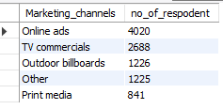

**##BRAND PENETRATION**

**#1.What do people think about our brand**

SELECT Brand_perception, COUNT(*) AS no_of_respodent_codex

FROM sample_data.fact_survey_responses

WHERE Current_brands='Codex'

GROUP BY Brand_perception

ORDER BY no_of_respodent_codex DESC;

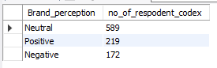

**#2.Which cities do we need to focus more on**

SELECT City, COUNT(dr.Respondent_ID) AS no_of_respodent_codex

FROM dim_repondents dr JOIN fact_survey_responses fsr ON dr.Respondent_ID=fsr.Respondent_ID JOIN dim_cities dc ON dc.City_ID=dr.City_ID

WHERE Current_brands='CodeX'

GROUP BY City

ORDER BY no_of_respodent_codex ;

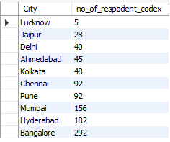

**#PURCHASE BEHAVIOR**

**#1.where do respodent prefer to purchase energy drinks?**

SELECT Purchase_location, COUNT(dr.Respondent_ID) AS no_of_respodent

FROM dim_repondents dr JOIN fact_survey_responses fsr ON dr.Respondent_ID=fsr.Respondent_ID

GROUP BY Purchase_location

ORDER BY no_of_respodent DESC;

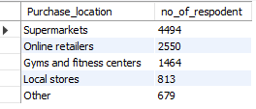

**#2 what are typical consumption situation for energy drink among respodents**

SELECT Typical_consumption_situations , COUNT(dr.Respondent_ID) AS no_of_respodent

FROM dim_repondents dr JOIN fact_survey_responses fsr ON dr.Respondent_ID=fsr.Respondent_ID

GROUP BY Typical_consumption_situations

ORDER BY no_of_respodent DESC;

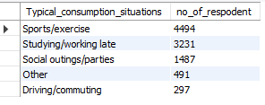

**#3.What factors influence respondents' purchase decisions, such as price range and limited edition packaging?**

SELECT Limited_edition_packaging, COUNT(dr.Respondent_ID) AS no_of_respodent

FROM dim_repondents dr JOIN fact_survey_responses fsr ON dr.Respondent_ID=fsr.Respondent_ID

GROUP BY Limited_edition_packaging

ORDER BY no_of_respodent DESC;

SELECT Price_range, COUNT(dr.Respondent_ID) AS no_of_respodent

FROM dim_repondents dr JOIN fact_survey_responses fsr ON dr.Respondent_ID=fsr.Respondent_ID

GROUP BY Price_range

ORDER BY no_of_respodent DESC;

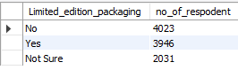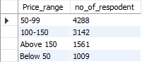

**#PRODUCT DEVELOPMENT**

**#1. Which area of business should we focus more on our product development? (Branding/taste/availability)**

SELECT Reasons_preventing_trying, COUNT(dr.Respondent_ID) AS no_of_respodent

FROM dim_repondents dr JOIN fact_survey_responses fsr ON dr.Respondent_ID=fsr.Respondent_ID

WHERE Current_brands='CodeX'

GROUP BY Reasons_preventing_trying

ORDER BY no_of_respodent DESC;

